**UML Diagram**

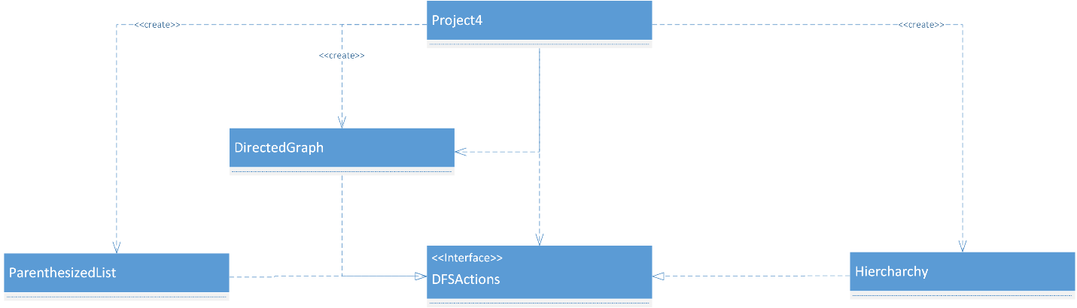

**Test cases**

1. case1.txt

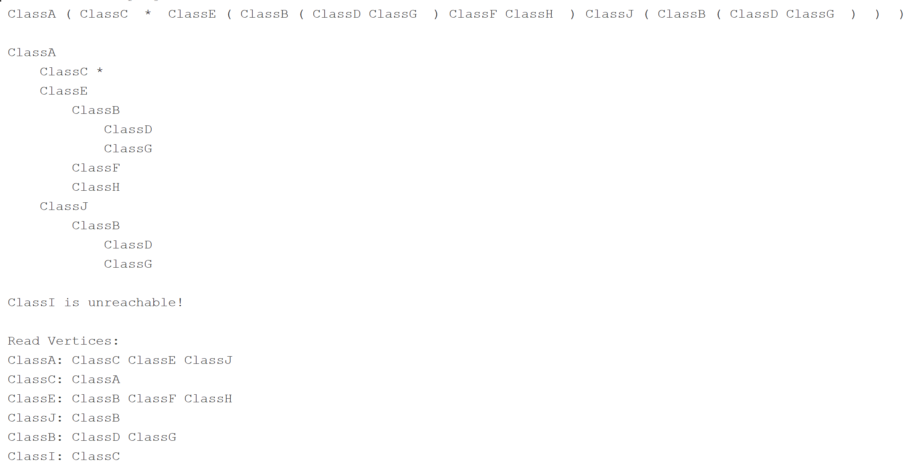

1. case2.txt

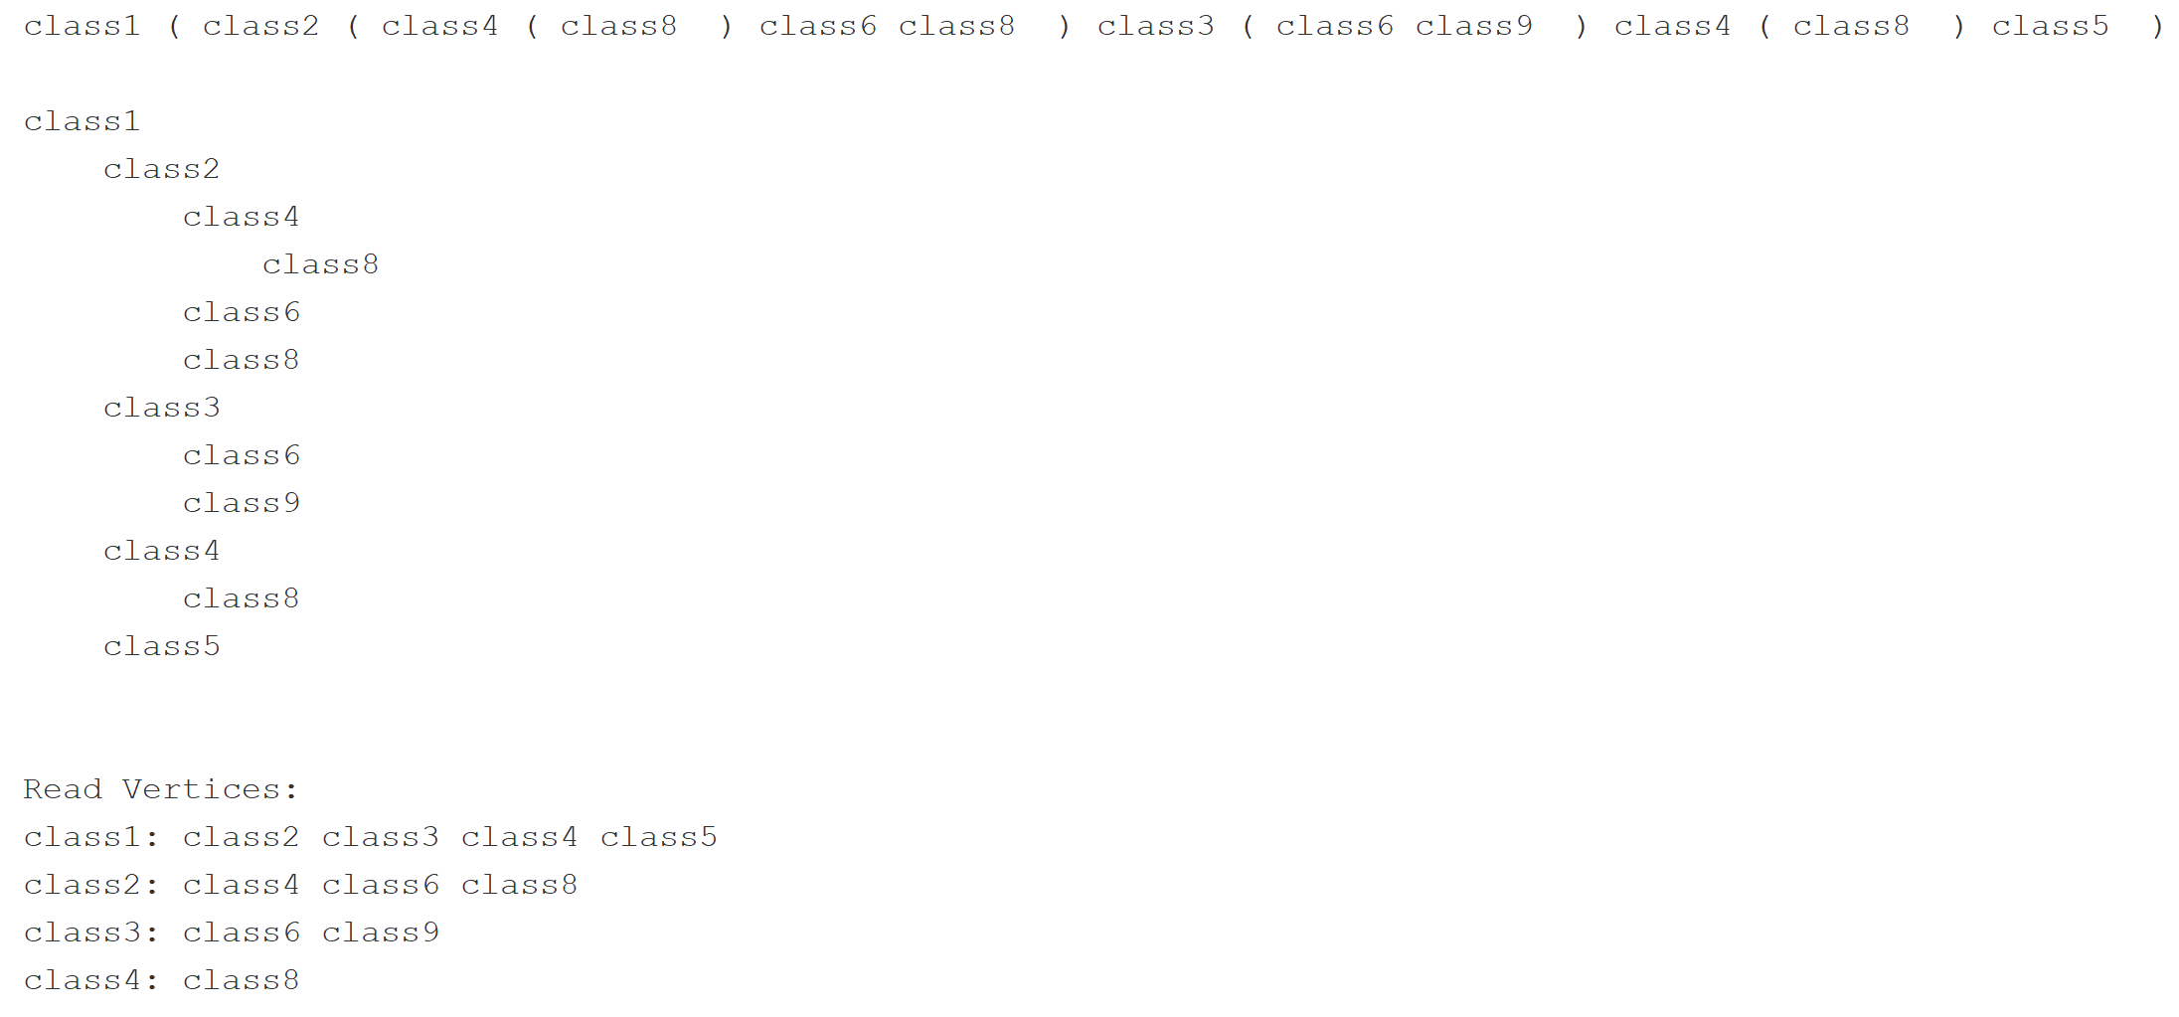

1. case3.txt

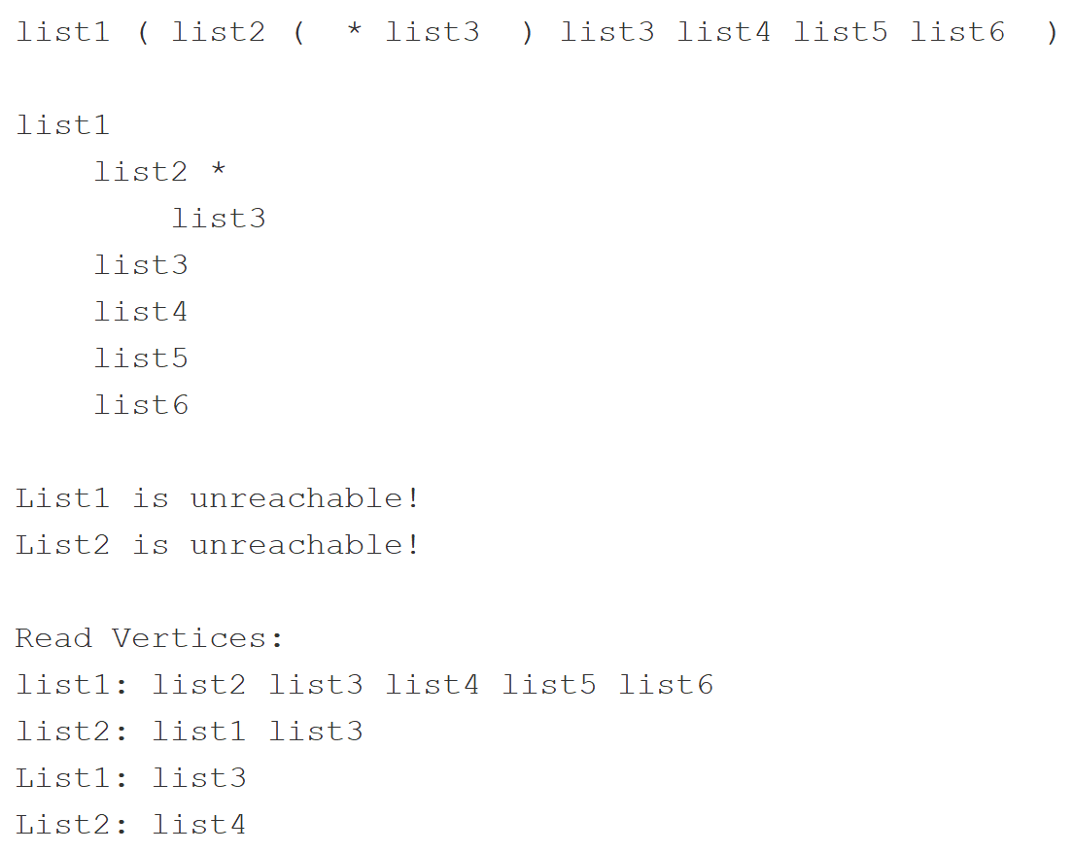

1. case4.txt

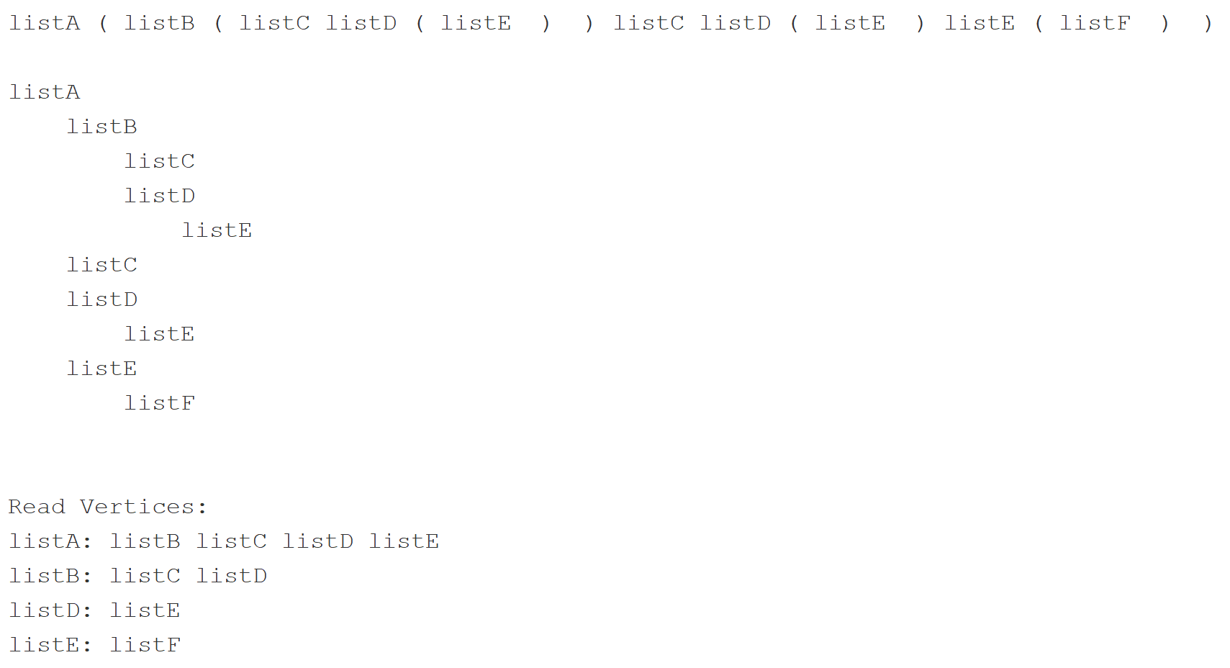

**Lessons learnt**

By doing this project, I learned a lot about the graph data structures, and implementing depth first search recursively. Also got more practice to handle linked lists (by implementing it through edge and vertices) as custom data structures. In future to reduce iterations/ computations, implementation of iterator by nested static class would do a better job. By implementing DFS I got more confident/ comfortable and developed much more understanding of the DFS algorithm.